***BAHRIA UNIVERSITY KARACHI CAMPUS***

**DATA COMMUNICATION & NETWORKING LAB**

**PROJECT REPORT**

**SPRING - 2023**

**UNIVERSITY MANAGEMENT SYSTEM**

**GROUP MEMBERS**

Muhammad Sharjeel Siddiqui (02- 235221-016)

Muhammad Umar Khan (02- 235221-021)

Abdul Ghaffar (02- 235221-009)

SUBMITTED ON

_____________



**Table of Contents**

1. Abstract
2. Introduction
3. Literature Review
4. Components
5. Network Diagram
6. Key Concepts of DCN
7. Implementation and Working
8. Results
9. Application/Features
10. Conclusion
11. References
12. **ABSTRACT:** The University Management System project focuses on building a secure and efficient network system using Cisco Packet Tracer. The system aims to allow smooth contact and data sharing among various departments within three sites, namely Karachi, Islamabad, and Lahore. The network design consists of routers, switches, and PCs, with specific entry limits and communication rules to ensure security and effective information flow. This study gives a thorough outline of the project, including its implementation, key ideas of data transfer and networking, results, wireless communication and controlling, and program features.
13. **INTRODUCTION:** The University Management System is intended to handle the contact and data-sharing needs of a university with various branches. By creating a stable network framework, the project aims to enhance cooperation, reduce administrative processes, and improve overall efficiency. This study shows the full design and implementation of the network, along with the reasoning behind the chosen components and setups.
14. **LITERATURE REVIEW:** This part reviews important literature on data transfer and networking, especially focused on network design, route protocols, switch setups, and access control methods. It covers current studies and best practices in building large-scale network systems for educational institutions.
15. **COMPONENTS / TOOLS:** The network system for the University Management System consists of three schools, each equipped with a router and linked to a main department switch. The main router is connected to each campus’s router. Additionally, three switches are linked to each main department switch, symbolizing the Student, Faculty, and SSC offices. There is separate IoT integration for the SSC department to make sure that all operations in this department work perfectly.
16. **NETWORK DIAGRAM:**

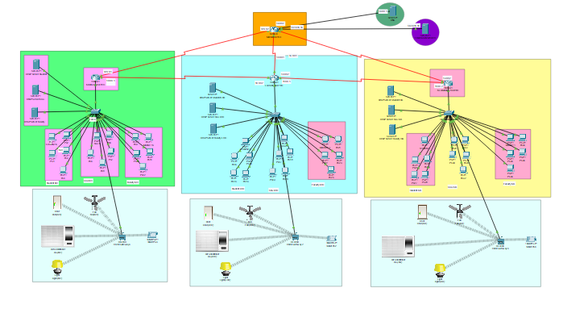

1. **KEY CONCEPTS OF DCN:**
2. IP addressing:

* Overview of IP addressing
* IP addressing
* Classes of IP addresses (Class A, B, C, D, E)
* IP address allocation and subnetting

1. VLANs (Virtual Local Area Networks):

* Introduction to VLANs and their benefits
* VLAN tagging and trunking
* VLAN configuration and management
* Inter-VLAN communication and VLAN routing

1. Routing protocols:

* Routing basics and concepts
* Interior and exterior routing protocols
* Configuring routing protocols

1. Access control lists (ACLs):

* Introduction to ACLs and their purpose
* Types of ACLs (standard and extended)
* ACL rules and syntax
* Applying ACLs for traffic filtering and security

1. IoT (Internet of Things):

* Wireless controls for Ac, fans, lights, and doors for the SSC department of all campuses

These concepts cover important topics related to IP addressing, subnetting, VLANs, routing protocols, IoT, and access control lists. They provide a solid foundation for understanding and implementing the network design for the University Management System project.

1. **IMPLEMENTATION & WORKING:** This part explains the step-by-step application of the network plan using the Cisco Packet Tracer. It covers the setup information of routers, switches, VLANs, routing protocols, IoT, and access control lists. The study shows how the network is organized to allow contact between departments, schools, and the Facebook computer, while keeping access limits as per the project requirements.

#### **RESULTS:** This section presents the key outcomes and performance metrics of the implemented network infrastructure. It provides a comprehensive analysis of network latency, throughput, and reliability measurements, highlighting the effectiveness and efficiency of the network design. The report also delves into the challenges encountered during the implementation and demonstrates how they were successfully addressed to ensure optimal network performance and functionality.

#### **APPLICATION / FEATURES:** This part shows the useful uses and features of the University Management System. It shows how the network framework allows efficient contact, data sharing, and teamwork among offices and schools. Additionally, it stresses the private contact between teachers and SSC departments with the Facebook site.

#### **CONCLUSION:** The University Management System project successfully builds a network architecture that allows smooth contact and data sharing within and across departments in multiple schools. The applied design provides safe access to the Facebook server for teachers and SSC offices while allowing inter-departmental contact. The project's results show the usefulness and speed of the network design in serving the university's management system.

#### **REFERENCES:** We took references from scholarly papers, textbooks, and online tools connected to data communication, networking, network design, and different websites.

<https://www.computernetworkingnotes.com/ccna-study-guide/configure-standard-access-control-list-step-by-step-guide.html>

<https://computernetworking747640215.wordpress.com/2018/07/05/vlan-configuration-on-a-cisco-switch-in-packet-tracer/>